**SE401: Software Quality Assurance & Testing**

# Activity 5.2-JUnit and Coverage Testing

## Objective:

Learn how to use

* JUnit for unit level testing
* EclEmma to measure the coverage of Unit Testing.

## Setup Instructions:

* Install the latest Version of [Eclipse](https://eclipse.org/downloads/).
* On opening the link, select Windows/Mac OS X from the drop down Menu. Download **Eclipse IDE for Java Developers 64 bit.**
* We need the latest version of Eclipse to use some tools throughout the course
* Eclipse requires Java to be installed on your machine. Make sure the chosen Eclipse architecture matches your chosen Java architecture!

## Assignment:

* Start Eclipse.
* If you need help using Eclipse, see the tutorial.
* We will be using the CoffeeMaker example for unit level testing and measuring the coverage.
* Extract the zip file ‘CoffeeMaker_JUnit’and import the CoffeeMaker Junit project in Eclipse.
* Unit Testing using JUnit:
  + Follow the instructions in the Unit Testing in Eclipse using JUnit tutorial. You can ignore everything about FIT tests, such as the instructions for putting junit.jar on your build path. (The main thing is to download and work with the CoffeeMaker project.)
  + Create unit tests and fix the 5 bugs. Use JUnit to confirm that the bugs are fixed.
* Coverage using EclEmma:
  + We will be using Emma to perform the coverage tests.
  + Install **EclEmma Java Code Coverage** plugin: Open Eclipse > Help > Eclipse Marketplace > search for 'EclEmma' > click Install
  + Read about EclEmma and test coverage [here](http://www.eclemma.org/)
  + Create unit tests to achieve 90% Coverage of the CoffeeMaker, Inventory, Recipe, & Recipe Book classes.

## Submission Instructions:

* You will submit Unit Tests for CoffeMaker, Inventory, Recipe and RecipeBook java classes. (4 classes in total).
* Submit screenshots of passing JUnit tests and Emma tests a very brief explanation of what you did to accomplish the activity including test cases. The java class NOT the Test class should cover 90% of the code from Emma.
* Example Screen shot of Submission. Notice we are looking at the % coverage of edu.ncsu.csc326.coffeemaker

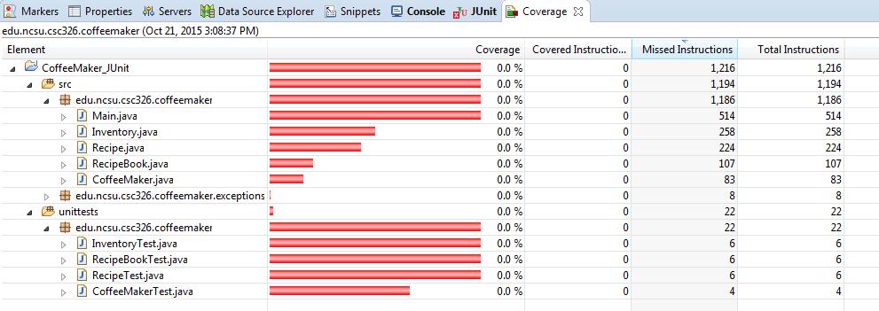

* Create a word Document and then convert it to PDF
* Write explanation and place the screenshots in the same PDF
* Submit in PDF format only.
* Submit the results of JUnit and Emma in a single PDF.

